Library Management System Specification

Library Management System
The Library Management System is designed to digitize the book borrowing and returning process, manage users, and store data centrally with the following core features:

View and Search Documents:
- Both Guests and Members can search for books using various filters: Search by publication date, Search by author, Search by title, and Search by subject.
- Customers can view the book catalog (Search catalog) and view detailed information for each individual book (View book details).

User Account Management:
- Unregistered users (Guests) can use the Register function to create a library card.
- Members and Administrators (Admins) are required to Login to use advanced privileges. They can View Account, Update account, use the Forgot password feature, and Logout.

Book Borrowing/Returning Process (For Members):
- Members can send various types of requests (Send Request) including: Request borrow book, Request return book, Request reserve book, and Request renew book.
- Members can Report issue of the book if damage is detected, and Pay fine if any violations occur.

System Administration Process (For Admins):
- Manage book: Admins have full rights to Add books, Edit books, and Remove books from the catalog.
- Manage member: Admins can View member, Add member, Update member, and Suspend member.
- Approve request: Admins process requests from Members such as Approve borrow book, Approve return book, Approve renew book, and Approve reserve book.
- Violation Management: Admins are responsible to Check condition of the book upon return and Fine the member if issues are found.

Non-Functional Requirements
- Maintainability: The software source code must be written with a clean structure to easily evolve and adapt to future customer changing needs.
- Design Constraints: MySQL, PostgreSQL, C++,
- Dependability & Security: Ensure data security; user passwords must be encrypted. The system must possess high reliability, minimizing downtime.
- Efficiency: Avoid wasting system resources (RAM, CPU), ensuring a quick response time even when thousands of students access and search simultaneously.
- Usability: User-friendly interface, easy to operate for students and librarians.
- Availbility: Students and librarians can access 24/7, except for scheduled system maintenance periods, about which students will be notified in advance via email.
- Confidentiality: When processing a payment, the software will not save the customer's entered card information.

Data Flow Diagram
Description of data movement within the system
DFD Level 0 (Context Diagram): Illustrates the high-level interaction between 3 External Entities (Guest, Member, Admin) with a single process named "Library Management System". Flowing data includes login information, borrow/return requests, and approval decisions.
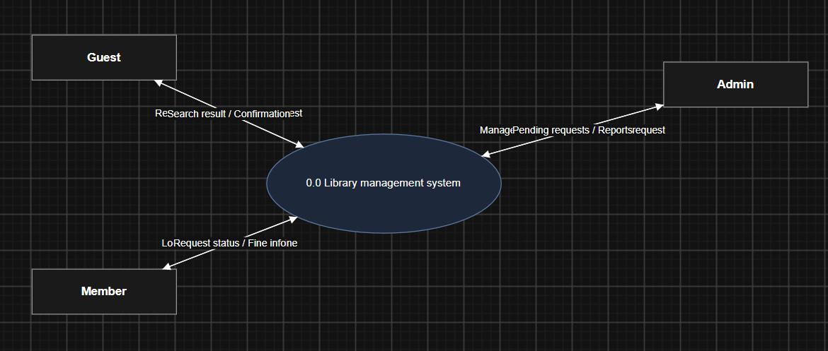
DFD Level 1: Decomposes the system into 5 core processes: (1.0) Account self-service, (2.0) Manage members, (3.0) Search/Manage catalog, (4.0) Process request, (5.0) Fine management. These processes interact with 5 Data Stores: User DB, Book DB, Request DB, BorrowRecord DB, and Fine DB.
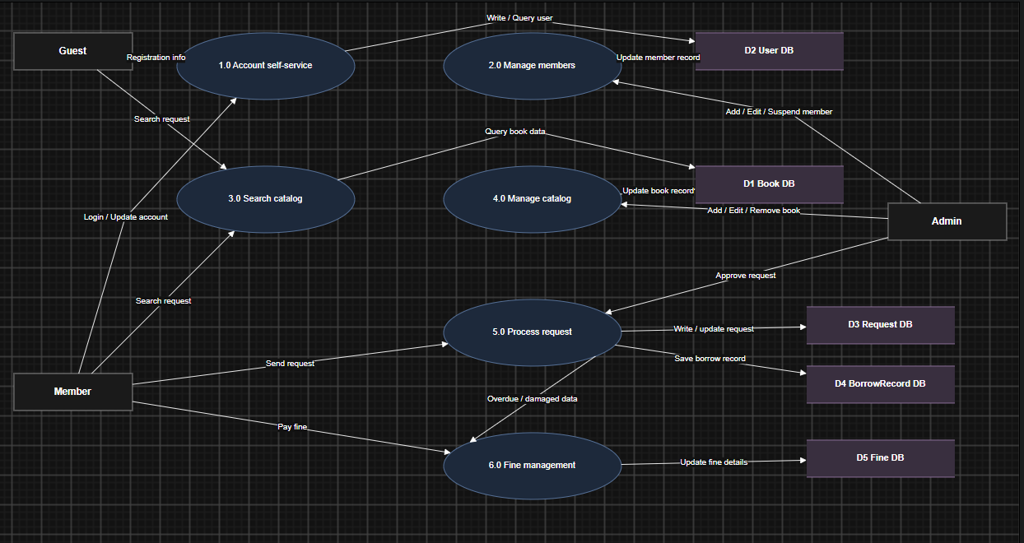

Use-Case Diagram
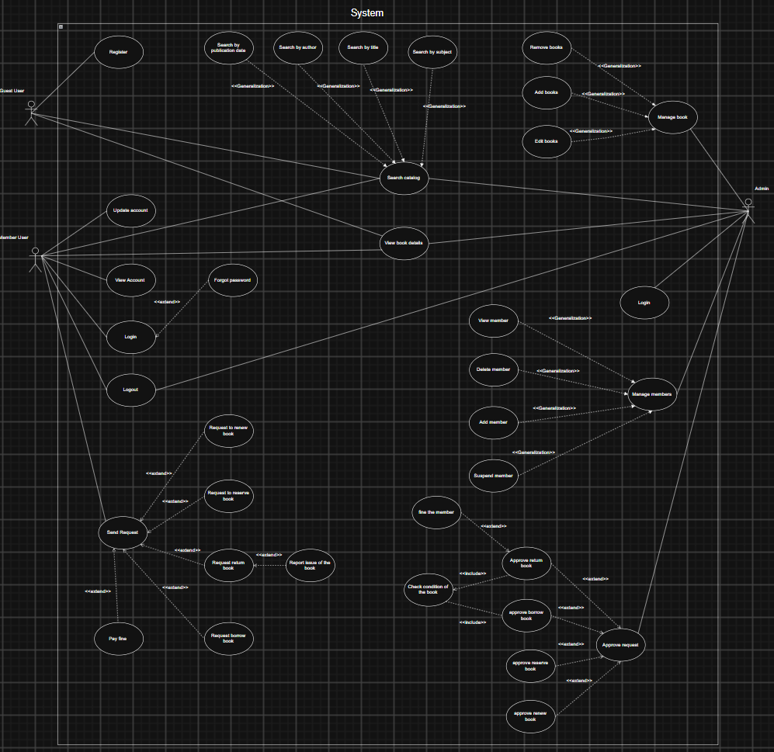

List of Actors:
No. | Use-case | Meaning
1 | Guest | Guest, a user who has not logged into the system.
2 | Member | Member, a user who has an account and is logged in.
3 | Admin | System administrator / Librarian.

List of Use-cases:
UC-ID | Use Case name | Meaning
UC-01 | Register | Register for who does not have an account
UC-02 | Login | Authenticate member access
UC-03 | Forgot password | Reset member password
UC-04 | Logout | End member session
UC-05 | View Account | View member profile
UC-06 | Update account | Modify member profile
UC-07 | Search catalog | General search for books
UC-08 | Search by publication date | Search books by date
UC-09 | Search by author | Search books by author
UC-10 | Search by title | Search books by title
UC-11 | Search by subject | Search books by subject
UC-12 | View book details | View specific book information
UC-13 | Send Request | General request submission
UC-14 | Request to renew book | Submit request to renew
UC-15 | Request to reserve book | Submit request to reserve
UC-16 | Request return book | Submit request to return
UC-17 | Report issue of the book | Submit request to report the issue of the book
UC-18 | Request borrow book | Submit request to borrow
UC-19 | Pay fine | Pay overdue/damage fines
UC-20 | Manage book | General book management
UC-21 | Add books | Add new books to inventory
UC-22 | Edit books | Modify book details
UC-23 | Remove books | Delete books from inventory
UC-24 | Manage members | General member management
UC-25 | View member | General member management
UC-26 | Add member | Create new member account at library
UC-27 | Delete member | Remove member account
UC-28 | Suspend member | Temporarily block
UC-29 | Login (Admin) | Authenticate admin access
UC-30 | Approve request | General request approval
UC-31 | Approve borrow book | Approve borrow request
UC-32 | Approve return book | Approve return request
UC-33 | Approve reserve book | Approve reserve request
UC-34 | Approve renew book | Approve renew request
UC-35 | fine the member | Issue fine to member
UC-36 | Check condition of the book | Verify physical book status

UC-01: Register Account
1. Overview
Use Case ID: UC-01
Use Case Name: Register Account
Primary Actor: Guest User
Secondary Actor: Email/Notification Service
Description: Enables a guest to create a new member account so they can access member-only features of the library system.
2. Conditions
Pre-condition: The user does not yet have an account and is on the registration page.
Post-condition: A new Member User account is created in the system, in "active" or "pending activation" status.
3. Flow of Events
Basic Flow:
1. Guest User selects "Register".
2. The system displays the registration form (name, email, password, contact information, etc.).
3. Guest User enters the required information and submits the form.
4. The system validates the data (email format, email uniqueness, password strength).
5. The system creates the new account and stores it in the database.
6. The system sends a confirmation email/notification to the user.
Alternative Flow: None.
Exception Flow:
If the email address is already registered, the system displays an error and asks the user to use a different email or log in instead.
If any required field is invalid or missing, the system highlights the field and displays a validation message.
4. Additional Information
Business Rules:
Email address must be unique across the system.
Password must meet the minimum complexity policy (e.g., minimum 8 characters, at least one number).
Non-Functional Requirements: The registration confirmation must be sent within a few seconds of successful submission; the form must validate input in real time.

UC-02: Log In (Member)
1. Overview
Use Case ID: UC-02
Use Case Name: Log In (Member)
Primary Actor: Member User
Secondary Actor: —
Description: Allows a registered member to authenticate and gain access to their account and member features.
2. Conditions
Pre-condition: The user already has a valid, active account.
Post-condition: The user is authenticated and an active session is created; the user is redirected to the member home page.
3. Flow of Events
Basic Flow:
1. The user enters their email/username and password.
2. The system validates the credentials against stored account data.
3. The system creates a session and redirects the user to the member home page.
Alternative Flow: If the user has forgotten their password, they select "Forgot password", which triggers UC-03: Reset Password.
Exception Flow:
If the credentials are incorrect, the system displays an error message and allows the user to retry.
If the account is suspended (see UC-28), the system denies login and displays the suspension reason.
4. Additional Information
Business Rules: An account is locked for a period of time after 5 consecutive failed login attempts.
Non-Functional Requirements: Authentication should complete within 2 seconds under normal load; passwords must be stored using a secure hashing algorithm.

UC-03: Reset Password
1. Overview
Use Case ID: UC-03
Use Case Name: Reset Password
Primary Actor: Member User
Secondary Actor: Email/Notification Service
Description: Allows a user who has forgotten their password to regain access to their account by setting a new password.
2. Conditions
Pre-condition: The user is on the login screen and selects "Forgot password".
Post-condition: The account password is updated; the user can log in with the new password.
3. Flow of Events
Basic Flow:
1. The user enters their registered email address.
2. The system verifies the email exists and sends a password-reset link/code.
3. The user opens the link/enters the code and sets a new password.
4. The system updates the stored password.
Alternative Flow: None.
Exception Flow:
If the email is not registered in the system, the system displays a generic message without revealing whether the account exists (for security).
If the reset link/code has expired, the system asks the user to request a new one.
4. Additional Information
Business Rules: A reset link/code is valid for a limited time (e.g., 30 minutes) and can be used only once.
Non-Functional Requirements: The reset email should be delivered within 1 minute of the request.

UC-04: Log Out
1. Overview
Use Case ID: UC-04
Use Case Name: Log Out
Primary Actor: Member User
Secondary Actor: —
Description: Allows a logged-in member to safely end their current session.
2. Conditions
Pre-condition: The user is logged in.
Post-condition: The session is terminated and the user is redirected to the login/home page.
3. Flow of Events
Basic Flow:
1. The user selects "Logout".
2. The system terminates the active session and clears session data.
3. The system redirects the user to the login/home page.
Alternative Flow: None.
Exception Flow: None.
4. Additional Information
Business Rules: None.
Non-Functional Requirements: Logout must complete immediately (under 1 second) to prevent unauthorized access from a shared device.

UC-05: View Account Information
1. Overview
Use Case ID: UC-05
Use Case Name: View Account Information
Primary Actor: Member User
Secondary Actor: —
Description: Allows a member to view their personal information along with borrowing history and outstanding fines.
2. Conditions
Pre-condition: The user is logged in.
Post-condition: Account details are displayed to the user; no data is modified.
3. Flow of Events
Basic Flow:
1. The user selects "View Account".
2. The system retrieves and displays the account's personal information, currently borrowed books, and outstanding fines.
Alternative Flow: None.
Exception Flow: If account data cannot be retrieved due to a system error, an error message is displayed.
4. Additional Information
Business Rules: None.
Non-Functional Requirements: Account information must load within 2 seconds.

UC-06: Update Account Information
1. Overview
Use Case ID: UC-06
Use Case Name: Update Account Information
Primary Actor: Member User
Secondary Actor: —
Description: Allows a member to edit their personal information such as address, phone number, or password.
2. Conditions
Pre-condition: The user is logged in.
Post-condition: The account information is updated in the database.
3. Flow of Events
Basic Flow:
1. The user selects "Update Account".
2. The system displays the current information in an editable form.
3. The user edits the desired fields and submits.
4. The system validates and saves the updated information.
Alternative Flow: None.
Exception Flow: If the submitted data is invalid (e.g., malformed phone number), the system displays a validation error and does not save the changes.
4. Additional Information
Business Rules: Certain fields (e.g., member ID, registration date) cannot be edited by the member.
Non-Functional Requirements: Changes must be saved and reflected immediately after submission.

Group B – Search & Book Browsing

UC-07: Search Catalog
1. Overview
Use Case ID: UC-07
Use Case Name: Search Catalog
Primary Actor: Guest User, Member User, Admin
Secondary Actor: —
Description: The general (abstract) use case for searching the library catalog; realized concretely through UC-08 to UC-11 (search by publication date, author, title, and subject).
2. Conditions
Pre-condition: None (login is not required).
Post-condition: A list of matching books is displayed to the user.
3. Flow of Events
Basic Flow:
1. The user selects a search criterion and enters a search term.
2. The system queries the book database using the selected criterion.
3. The system displays the list of matching results, or an empty-result message.
Alternative Flow: None.
Exception Flow: If the search service is unavailable, the system displays an error message.
4. Additional Information
Business Rules: None.
Non-Functional Requirements: Search results should return within 2–3 seconds for typical catalog sizes.

UC-08: Search Books by Publication Date
1. Overview
Use Case ID: UC-08
Use Case Name: Search Books by Publication Date
Primary Actor: Guest User, Member User, Admin
Secondary Actor: —
Description: A <<Generalization>> variant of UC-07 that filters the catalog by publication date or date range.
2. Conditions
Pre-condition: None.
Post-condition: Books matching the specified publication date/range are displayed.
3. Flow of Events
Basic Flow: Same as UC-07, with the search criterion fixed to publication date.
Alternative Flow: None.
Exception Flow: Same as UC-07.
4. Additional Information
Business Rules: None.
Non-Functional Requirements: Same as UC-07.

UC-09: Search Books by Author
1. Overview
Use Case ID: UC-09
Use Case Name: Search Books by Author
Primary Actor: Guest User, Member User, Admin
Secondary Actor: —
Description: A <<Generalization>> variant of UC-07 that filters the catalog by author name.
2. Conditions
Pre-condition: None.
Post-condition: Books matching the specified author are displayed.
3. Flow of Events
Basic Flow: Same as UC-07, with the search criterion fixed to author.
Alternative Flow: None.
Exception Flow: Same as UC-07.
4. Additional Information
Business Rules: None.
Non-Functional Requirements: Same as UC-07.

UC-10: Search Books by Title
1. Overview
Use Case ID: UC-10
Use Case Name: Search Books by Title
Primary Actor: Guest User, Member User, Admin
Secondary Actor: —
Description: A <<Generalization>> variant of UC-07 that filters the catalog by book title.
2. Conditions
Pre-condition: None.
Post-condition: Books matching the specified title are displayed.
3. Flow of Events
Basic Flow: Same as UC-07, with the search criterion fixed to title.
Alternative Flow: None.
Exception Flow: Same as UC-07.
4. Additional Information
Business Rules: None.
Non-Functional Requirements: Same as UC-07.

UC-11: Search Books by Subject
1. Overview
Use Case ID: UC-11
Use Case Name: Search Books by Subject
Primary Actor: Guest User, Member User, Admin
Secondary Actor: —
Description: A <<Generalization>> variant of UC-07 that filters the catalog by subject/genre.
2. Conditions
Pre-condition: None.
Post-condition: Books matching the specified subject are displayed.
3. Flow of Events
Basic Flow: Same as UC-07, with the search criterion fixed to subject.
Alternative Flow: None.
Exception Flow: Same as UC-07.
4. Additional Information
Business Rules: None.
Non-Functional Requirements: Same as UC-07.

UC-12: View Book Details
1. Overview
Use Case ID: UC-12
Use Case Name: View Book Details
Primary Actor: Guest User, Member User, Admin
Secondary Actor: —
Description: Allows a user to view detailed information about a specific book title, including availability status.
2. Conditions
Pre-condition: The user has search results or has selected a book from the catalog.
Post-condition: Detailed book information is displayed; no data is modified.
3. Flow of Events
Basic Flow:
1. The user selects a book from a list.
2. The system retrieves and displays full details (author, description, shelf location, availability status, etc.).
Alternative Flow: None.
Exception Flow: If the book record no longer exists, the system displays a "not found" message.
4. Additional Information
Business Rules: None.
Non-Functional Requirements: Book details must load within 2 seconds.

Group C – Member Requests (Borrow / Return / Renew)

UC-13: Send Request
1. Overview
Use Case ID: UC-13
Use Case Name: Send Request
Primary Actor: Member User
Secondary Actor: Admin
Description: The base use case representing a member submitting a request to the library; extended by the specific request types (borrow, reserve, renew, return, pay fine).
2. Conditions
Pre-condition: The user is logged in.
Post-condition: The request is stored with status "Pending" and made visible to the Admin for processing (linked to UC-30: Approve Request).
3. Flow of Events
Basic Flow:
1. The Member User selects the type of request to submit.
2. The system collects the necessary details for that request type.
3. The system creates a request record with status "Pending".
4. The system notifies the Admin of the new request.
Alternative Flow: None.
Exception Flow: If the member has an unresolved issue (e.g., a suspended account or overdue fine, depending on business rules), the system may block submission and display the reason.
4. Additional Information
Business Rules: A member may have only one active request of a given type for the same book at a time.
Non-Functional Requirements: Request submission must be confirmed to the user within 2 seconds.

UC-14: Request to Renew Book
1. Overview
Use Case ID: UC-14
Use Case Name: Request to Renew Book
Primary Actor: Member User
Secondary Actor: Admin
Description: Allows a member to request an extension of the borrowing period for a currently borrowed book.
2. Conditions
Pre-condition: The member currently has the book borrowed and it is not yet overdue.
Post-condition: A renewal request is created with status "Pending", awaiting UC-34: Approve Renewal Request.
3. Flow of Events
Basic Flow:
1. The user selects a currently borrowed book.
2. The user selects "Renew".
3. The system records the renewal request and submits it for approval.
Alternative Flow: None.
Exception Flow: If the book has already reached the maximum number of renewals, or another member has reserved it, the system rejects the request and explains why.
4. Additional Information
Business Rules:
A book may be renewed a maximum of 2 times.
A book with an active reservation from another member cannot be renewed.
Non-Functional Requirements: None beyond standard responsiveness.

UC-15: Request to Reserve Book
1. Overview
Use Case ID: UC-15
Use Case Name: Request to Reserve Book
Primary Actor: Member User
Secondary Actor: Admin
Description: Allows a member to reserve a book that is currently unavailable (borrowed by another member).
2. Conditions
Pre-condition: The selected book is currently unavailable.
Post-condition: A reservation request is created with status "Pending", awaiting UC-33: Approve Reservation Request.
3. Flow of Events
Basic Flow:
1. The user selects an unavailable book.
2. The user selects "Reserve".
3. The system records the reservation request and adds the member to the reservation queue for that book.
Alternative Flow: None.
Exception Flow: If the member already has an active reservation for the same title, the system prevents a duplicate reservation.
4. Additional Information
Business Rules: Reservations are honored in first-come, first-served order.
Non-Functional Requirements: None beyond standard responsiveness.

UC-16: Request to Return Book
1. Overview
Use Case ID: UC-16
Use Case Name: Request to Return Book
Primary Actor: Member User
Secondary Actor: Admin
Description: Allows a member to notify the library of returning a currently borrowed book.
2. Conditions
Pre-condition: The member currently has the book borrowed.
Post-condition: A return request is created with status "Pending", awaiting UC-32: Approve Return Request.
3. Flow of Events
Basic Flow:
1. The user selects a currently borrowed book.
2. The user selects "Return".
3. The system records the return request.
Alternative Flow: If the book being returned has an issue (damaged, missing pages, etc.), the user additionally triggers UC-17: Report Book Issue before or during submission.
Exception Flow: None.
4. Additional Information
Business Rules: None.
Non-Functional Requirements: None beyond standard responsiveness.

UC-17: Report Book Issue
1. Overview
Use Case ID: UC-17
Use Case Name: Report Book Issue
Primary Actor: Member User
Secondary Actor: Admin
Description: Allows a member to report the physical condition or issue of a book at the time of return.
2. Conditions
Pre-condition: This occurs as part of the return-book flow (UC-16).
Post-condition: Issue details are attached to the associated return request for the Admin's review.
3. Flow of Events
Basic Flow:
1. The user describes the issue (torn pages, missing pages, damaged cover, etc.), optionally with photos.
2. The system attaches this information to the return request.
Alternative Flow: None.
Exception Flow: None.
4. Additional Information
Business Rules: A reported issue may result in a fine per UC-35: Fine Member, subject to Admin review.
Non-Functional Requirements: None.

UC-18: Request to Borrow Book
1. Overview
Use Case ID: UC-18
Use Case Name: Request to Borrow Book
Primary Actor: Member User
Secondary Actor: Admin
Description: Allows a member to request borrowing an available book.
2. Conditions
Pre-condition: The selected book is currently available.
Post-condition: A borrow request is created with status "Pending", awaiting UC-31: Approve Borrow Request.
3. Flow of Events
Basic Flow:
1. The user selects an available book.
2. The user selects "Borrow".
3. The system records the borrow request.
Alternative Flow: None.
Exception Flow: If the member has reached the maximum number of concurrently borrowed books or has unpaid fines, the system rejects the request and explains why.
4. Additional Information
Business Rules:
A member may borrow a maximum of 5 books at a time.
A member with unpaid fines above a set threshold cannot submit new borrow requests.
Non-Functional Requirements: None beyond standard responsiveness.

UC-19: Pay Fine
1. Overview
Use Case ID: UC-19
Use Case Name: Pay Fine
Primary Actor: Member User
Secondary Actor: Payment Gateway
Description: Allows a member to pay an outstanding fine incurred from late returns or book damage.
2. Conditions
Pre-condition: The member's account has an unpaid fine.
Post-condition: The fine is marked as "Paid" and the corresponding restriction on the account (if any) is lifted.
3. Flow of Events
Basic Flow:
1. The user selects the outstanding fine.
2. The user selects a payment method and confirms payment.
3. The system processes the payment and updates the fine status to "Paid".
Alternative Flow: None.
Exception Flow: If payment processing fails, the system displays an error and the fine remains "Unpaid".
4. Additional Information
Business Rules: None.
Non-Functional Requirements: Payment confirmation must be processed securely and within the response time of the payment gateway used.

Group D – Book Management (Admin)

UC-20: Manage Books
1. Overview
Use Case ID: UC-20
Use Case Name: Manage Books
Primary Actor: Admin
Secondary Actor: —
Description: The general (abstract) use case for book catalog management; realized concretely through UC-21 (Add), UC-22 (Edit), and UC-23 (Remove).
2. Conditions
Pre-condition: The Admin is logged in.
Post-condition: Depends on the concrete operation performed.
3. Flow of Events
Basic Flow: N/A — see UC-21, UC-22, UC-23.
Alternative Flow: None.
Exception Flow: None.
4. Additional Information
Business Rules: None.
Non-Functional Requirements: None.

UC-21: Add Book
1. Overview
Use Case ID: UC-21
Use Case Name: Add Book
Primary Actor: Admin
Secondary Actor: —
Description: Allows the Admin to add a new book title to the catalog.
2. Conditions
Pre-condition: The Admin is logged in.
Post-condition: A new book record is created and appears in catalog search results.
3. Flow of Events
Basic Flow:
1. The Admin selects "Add Book".
2. The Admin enters the book information (title, author, genre, quantity, ISBN, etc.).
3. The system validates the data.
4. The system saves the new book to the catalog.
Alternative Flow: None.
Exception Flow: If required fields are missing or the ISBN is a duplicate, the system displays a validation error.
4. Additional Information
Business Rules: ISBN must be unique in the catalog.
Non-Functional Requirements: None.

UC-22: Edit Book
1. Overview
Use Case ID: UC-22
Use Case Name: Edit Book
Primary Actor: Admin
Secondary Actor: —
Description: Allows the Admin to update information for an existing book title.
2. Conditions
Pre-condition: The book already exists in the catalog.
Post-condition: The book's information is updated.
3. Flow of Events
Basic Flow:
1. The Admin selects the book to edit.
2. The system displays the current information.
3. The Admin updates the fields and saves.
4. The system validates and stores the changes.
Alternative Flow: None.
Exception Flow: If the updated data is invalid, the system displays a validation error and does not save.
4. Additional Information
Business Rules: None.
Non-Functional Requirements: None.

UC-23: Remove Book
1. Overview
Use Case ID: UC-23
Use Case Name: Remove Book
Primary Actor: Admin
Secondary Actor: —
Description: Allows the Admin to remove a book title from the catalog (e.g., disposal, loss, discontinued).
2. Conditions
Pre-condition: The book exists in the catalog.
Post-condition: The book is removed from (or archived out of) the catalog.
3. Flow of Events
Basic Flow:
1. The Admin selects the book to remove.
2. The Admin confirms the removal.
3. The system updates the catalog to remove the book.
Alternative Flow: None.
Exception Flow: If the book is currently borrowed or has active reservations, the system blocks the removal and displays a warning.
4. Additional Information
Business Rules: A book with active loans or reservations cannot be removed until those are resolved.
Non-Functional Requirements: None.

Group E – Member Management (Admin)

UC-24: Manage Members
1. Overview
Use Case ID: UC-24
Use Case Name: Manage Members
Primary Actor: Admin
Secondary Actor: —
Description: The general (abstract) use case for member management; realized concretely through UC-25 (View), UC-26 (Add), UC-27 (Delete), and UC-28 (Suspend).
2. Conditions
Pre-condition: The Admin is logged in.
Post-condition: Depends on the concrete operation performed.
3. Flow of Events
Basic Flow: N/A — see UC-25 through UC-28.
Alternative Flow: None.
Exception Flow: None.
4. Additional Information
Business Rules: None.
Non-Functional Requirements: None.

UC-25: View Member
1. Overview
Use Case ID: UC-25
Use Case Name: View Member
Primary Actor: Admin
Secondary Actor: —
Description: Allows the Admin to view the list of members and detailed information about a specific member.
2. Conditions
Pre-condition: The Admin is logged in.
Post-condition: Member information is displayed; no data is modified.
3. Flow of Events
Basic Flow:
1. The Admin selects "View Members".
2. The system displays the member list.
3. The Admin selects a member to view full details.
Alternative Flow: None.
Exception Flow: None.
4. Additional Information
Business Rules: None.
Non-Functional Requirements: None.

UC-26: Add Member
1. Overview
Use Case ID: UC-26
Use Case Name: Add Member
Primary Actor: Admin
Secondary Actor: —
Description: Allows the Admin to manually create a new member account, for example during in-person registration at the front desk.
2. Conditions
Pre-condition: The Admin is logged in.
Post-condition: A new member account is created.
3. Flow of Events
Basic Flow:
1. The Admin selects "Add Member".
2. The Admin enters the member's information.
3. The system validates and creates the account.
Alternative Flow: None.
Exception Flow: If the entered email/ID already exists, the system displays a duplicate error.
4. Additional Information
Business Rules: Email address must be unique across the system.
Non-Functional Requirements: None.

UC-27: Delete Member
1. Overview
Use Case ID: UC-27
Use Case Name: Delete Member
Primary Actor: Admin
Secondary Actor: —
Description: Allows the Admin to remove a member account from the system.
2. Conditions
Pre-condition: The member account exists.
Post-condition: The member account is deleted or deactivated.
3. Flow of Events
Basic Flow:
1. The Admin selects the member to delete.
2. The Admin confirms deletion.
3. The system removes/deactivates the account.
Alternative Flow: None.
Exception Flow: If the member currently has borrowed books or unpaid fines, the system warns the Admin and may block deletion until resolved.
4. Additional Information
Business Rules: A member with outstanding loans or fines cannot be deleted until those are cleared.
Non-Functional Requirements: None.

UC-28: Suspend Member
1. Overview
Use Case ID: UC-28
Use Case Name: Suspend Member
Primary Actor: Admin
Secondary Actor: —
Description: Allows the Admin to temporarily suspend a member's account, for example due to a policy violation or overdue fines.
2. Conditions
Pre-condition: The member account exists and is active.
Post-condition: The member's account status is changed to "Suspended", restricting login and new requests.
3. Flow of Events
Basic Flow:
1. The Admin selects the member to suspend.
2. The Admin selects "Suspend" and enters the reason.
3. The system updates the account status to "Suspended" and notifies the member.
Alternative Flow: None.
Exception Flow: None.
4. Additional Information
Business Rules: A suspended member cannot log in or submit new borrow/reserve/renew requests until reinstated.
Non-Functional Requirements: None.

UC-29: Log In (Admin)
1. Overview
Use Case ID: UC-29
Use Case Name: Log In (Admin)
Primary Actor: Admin
Secondary Actor: —
Description: Allows an administrator to authenticate with elevated privileges to access the admin dashboard.
2. Conditions
Pre-condition: The Admin has a valid administrator account.
Post-condition: The Admin is authenticated and redirected to the admin dashboard.
3. Flow of Events
Basic Flow:
1. The Admin enters administrator credentials.
2. The system authenticates the credentials and verifies admin privileges.
3. The system redirects the Admin to the admin dashboard.
Alternative Flow: None.
Exception Flow: If credentials are invalid or the account lacks admin privileges, the system denies access and displays an error.
4. Additional Information
Business Rules: Admin accounts require stronger password policies and may require multi-factor authentication.
Non-Functional Requirements: Admin authentication should include additional security logging for audit purposes.

Group F – Request Approval (Admin)

UC-30: Approve Request
1. Overview
Use Case ID: UC-30
Use Case Name: Approve Request
Primary Actor: Admin
Secondary Actor: Member User
Description: The base use case for the Admin reviewing and processing requests submitted by members; extended by the specific approval types (borrow, return, reserve, renew).
2. Conditions
Pre-condition: There is at least one request pending processing.
Post-condition: The request status is updated to "Approved" or "Rejected", and the member is notified.
3. Flow of Events
Basic Flow: N/A — see UC-31, UC-32, UC-33, UC-34.
Alternative Flow: None.
Exception Flow: None.
4. Additional Information
Business Rules: None.
Non-Functional Requirements: None.

UC-31: Approve Borrow Request
1. Overview
Use Case ID: UC-31
Use Case Name: Approve Borrow Request
Primary Actor: Admin
Secondary Actor: Member User
Description: Allows the Admin to review and approve a member's book-borrow request.
2. Conditions
Pre-condition: A borrow request exists with status "Pending".
Post-condition: The book status is updated to "Borrowed", a due date is recorded, and the member is notified.
3. Flow of Events
Basic Flow:
1. The Admin reviews the pending borrow request.
2. The system performs <<include>> UC-36: Check Book Condition before handover.
3. The Admin confirms approval.
4. The system updates the book status to "Borrowed", sets the due date, and notifies the member.
Alternative Flow: None.
Exception Flow: If the book fails the condition check (e.g., already reported damaged) or is no longer available, the Admin rejects the request and states the reason.
4. Additional Information
Business Rules: The default loan period is 14 days from the approval date.
Non-Functional Requirements: None.

UC-32: Approve Return Request
1. Overview
Use Case ID: UC-32
Use Case Name: Approve Return Request
Primary Actor: Admin
Secondary Actor: Member User
Description: Allows the Admin to review and process a member's book-return request.
2. Conditions
Pre-condition: A return request exists with status "Pending".
Post-condition: The book status is updated to "Available" (or "Under repair" if damaged), and the loan record is closed.
3. Flow of Events
Basic Flow:
1. The Admin reviews the pending return request.
2. The system performs <<include>> UC-36: Check Book Condition upon receiving the book back.
3. The Admin confirms the return.
4. The system updates the book status to "Available" and closes the loan record.
Alternative Flow: None.
Exception Flow: If the return is late or the book is found damaged during the condition check, this triggers UC-35: Fine Member.
4. Additional Information
Business Rules: A late fee accrues per day overdue, per the library's fine policy.
Non-Functional Requirements: None.

UC-33: Approve Reservation Request
1. Overview
Use Case ID: UC-33
Use Case Name: Approve Reservation Request
Primary Actor: Admin
Secondary Actor: Member User
Description: Allows the Admin to review and approve a member's book-reservation request.
2. Conditions
Pre-condition: A reservation request exists with status "Pending", and the book has become available.
Post-condition: The book is held for the requesting member for a limited pickup period.
3. Flow of Events
Basic Flow:
1. The Admin reviews the pending reservation request.
2. The Admin checks book availability.
3. The Admin confirms the reservation and the system holds the book for the member, notifying them of the pickup deadline.
Alternative Flow: None.
Exception Flow: If the reserved book is no longer available, the Admin rejects or defers the request.
4. Additional Information
Business Rules: A reserved book is held for a maximum of 3 days before the reservation expires.
Non-Functional Requirements: None.

UC-34: Approve Renewal Request
1. Overview
Use Case ID: UC-34
Use Case Name: Approve Renewal Request
Primary Actor: Admin
Secondary Actor: Member User
Description: Allows the Admin to review and approve a member's request to renew a borrowed book.
2. Conditions
Pre-condition: A renewal request exists with status "Pending".
Post-condition: The book's due date is extended and the loan record is updated.
3. Flow of Events
Basic Flow:
1. The Admin reviews the pending renewal request.
2. The Admin checks renewal eligibility (no pending reservations, renewal limit not exceeded).
3. The Admin confirms approval and the system updates the new due date.
Alternative Flow: None.
Exception Flow: If the book has active reservations or has already reached the maximum renewal count, the Admin rejects the request.
4. Additional Information
Business Rules: A book may be renewed a maximum of 2 times, and only if no other member has reserved it.
Non-Functional Requirements: None.

UC-35: Fine Member
1. Overview
Use Case ID: UC-35
Use Case Name: Fine Member
Primary Actor: Admin
Secondary Actor: Member User
Description: Allows the Admin to issue a fine to a member for a late return, book damage, or loss.
2. Conditions
Pre-condition: A violation was identified during UC-32: Approve Return Request (late return or damage).
Post-condition: A fine record is created and linked to the member's account, and the member is notified (relating to UC-19: Pay Fine).
3. Flow of Events
Basic Flow:
1. The system/Admin calculates the fine amount according to policy (e.g., per-day late fee, or replacement cost for damage).
2. The Admin confirms and records the fine on the member's account.
3. The system notifies the member of the new fine.
Alternative Flow: None.
Exception Flow: None.
4. Additional Information
Business Rules:
Late fee: a fixed amount per day overdue, up to a capped maximum.
Damage fee: assessed based on severity, up to the full replacement cost of the book.
Non-Functional Requirements: None.

UC-36: Check Book Condition
1. Overview
Use Case ID: UC-36
Use Case Name: Check Book Condition
Primary Actor: Admin
Secondary Actor: —
Description: A shared, mandatory step to inspect the physical condition of a book, required in both the borrow-approval (UC-31) and return-approval (UC-32) processes. This is modeled as <<include>> because it is mandatory shared behavior, unlike extend, which is optional.
2. Conditions
Pre-condition: The book is physically present for inspection (at handover or at return).
Post-condition: The book's condition (good/damaged) is recorded in the system.
3. Flow of Events
Basic Flow:
1. The Admin visually inspects the book.
2. The Admin records the condition (good/damaged) in the system.
Alternative Flow: None.
Exception Flow: If damage is found, the outcome feeds into the relevant flow (e.g., blocking a borrow approval, or triggering UC-35: Fine Member on return).
4. Additional Information
Business Rules: None.

Non-Functional Requirements: None.Class Diagram
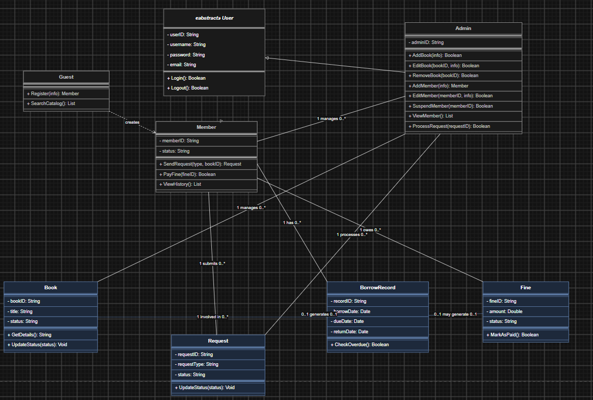

5. Class Diagram (Class Diagram Design)
The class diagram describes the static structure of the Library Management System, including entities (classes), attributes, processing methods, and relationships between them to serve the process of mapping to the Database.

5.1. Object Class Analysis
The system is divided into two main entity groups: User Group and Business Group.

A. User Group (Users):
- User (Abstract Class): An abstract class defining the most common attributes for all accounts in the system such as userID, username, password, email. This class contains basic authentication methods Login() and Logout().
- Guest: Represents a guest visitor. Contains SearchCatalog() for looking up and Register() to initialize a new Member account.
- Member: Inherits from User. Adds attributes memberID and status. This class handles borrower business methods: SendRequest(), PayFine(), and ViewHistory().
- Admin: Inherits from User. Adds the adminID attribute. This class contains all high-privilege methods for system administration: Add/Edit/Remove books (AddBook, EditBook, RemoveBook), Account management (AddMember, EditMember, SuspendMember, ViewMember), and Request processing (ProcessRequest).

B. Business Entities Group:
- Book: Manages book information with attributes bookID, title, status. Contains methods GetDetails() and UpdateStatus().
- Request: Manages user request tickets (borrow/return/renew) with requestID, requestType, status.
- BorrowRecord: Stores successful borrowing and returning history. Contains key timestamps: borrowDate, dueDate, returnDate. Features the CheckOverdue() function to check for overdue items.
- Fine: Manages penalties with fineID, amount, status (fine payment status). The MarkAsPaid() method is used to update the paid status.

